Student: Orazgul Garyagdyyeva

ISTG 6010-01

Object Oriented Systems

Prof Updyke, Dustin

9 April 2025

Battleship Game

Flow Diagram

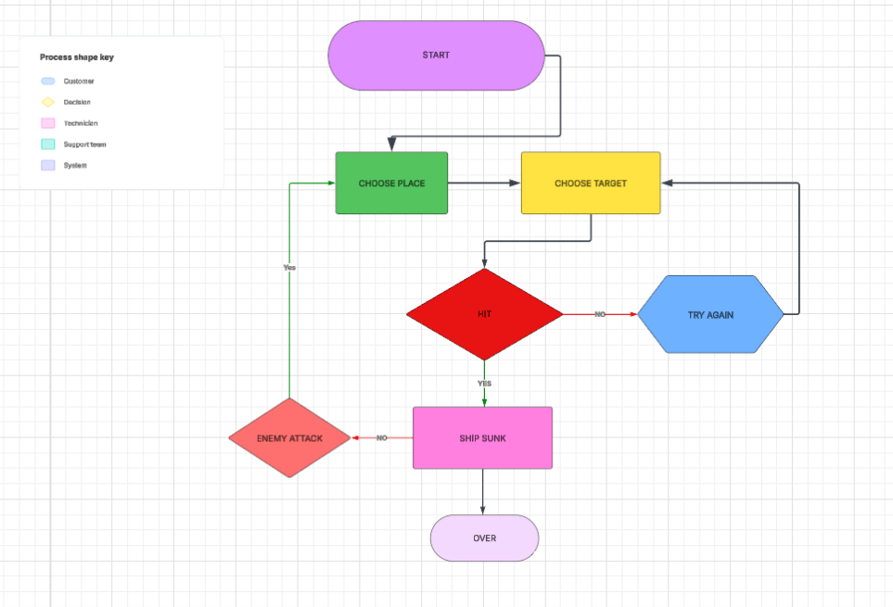

This Flow Diagram above represents a simplified use case flow for a RED player in the game Battleship. We better understand following a step-by-step sequence:

1. Start – The game begins, initializing the environment.  
 2. Choose Place – The player chooses where to position their ships on their grid.  
 3. Choose Target – Once setup is complete, the player selects a target location to fire at the enemy's grid.  
 4. Hit Evaluation – The system checks whether the selected target hits an enemy ship.  
 5. If Missed – The player must try again.  
 6. If Hit – The system checks if the ship has sunk.  
 7. Ship Sunk / Not Sunk – If a ship is sunk, the system records it. Otherwise, the enemy attacks.  
 8. Game Over – When one player's fleet is completely destroyed, the game ends.

UML DIAGRAM

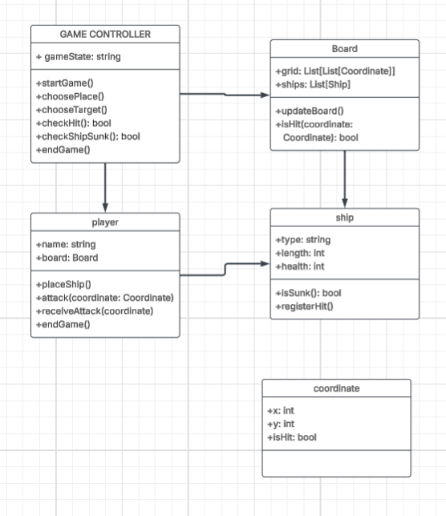

This UML diagram is a blueprint of how the software system might be structured using object-oriented programming. It includes five core classes:  
   
1. Game Controller (Control Object) – Coordinates the game flow, including setup, turns, and checking for win conditions.  
 2. Player (Boundary Object) – Represents each player in the game. It interacts with the user or opponent AI and manages the player’s board.  
 3. Board (Entity Object) – Holds a player's grid and ship placements.  
 4. Ship (Entity Object) – Represents individual ships with attributes like length and health.  
 5. Coordinate (Entity Object) – Represents positions on the grid with hit status.

Technical Object-Oriented Analysis

When developing software for the game Battleship, understanding the role of entity, boundary, and control objects is critical to effectively organize and manage the system.

Entity objects: These are the basic elements of data. In Battleship, the main classes are:

Ship: Contains information about ship type, length, and hit points.

Board: A two-dimensional grid on which ships are placed, and shots are tracked.

Coordinate: Represents an individual position on the board, with attributes for its location and whether it was hit.

Boundary objects: These interact with users or external systems. The Player class acts as a boundary object, handling player decisions such as placing ships and choosing attack coordinates. It serves as the interface between humans (or AI) and the internal logic of the game.

Control objects: These control the flow of the game. The Game Controller class is responsible for the overall game logic, including controlling the turn, allowing attacks, and determining the end of the game. It acts as a referee, organizing all interactions between objects.  
   
 The class structure supports principles of object-oriented programming:  
 Encapsulation – Each class keeps its behavior and data contained.  
 Abstraction – The diagram hides inner mechanics but shows clear roles.  
 Reusability – Code built on this model can be reused in variations of the game.